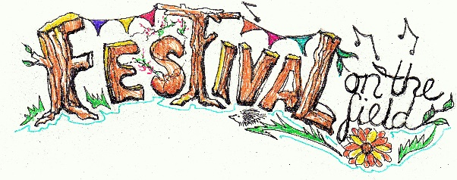
Festival on the Field

Squally showers, temperatures below 10°c, gusting winds. Not a great combination for a music festival and picnic! However, the ECA committee is not faint-hearted and so, on the Friday, decided that given all the preparations the inaugural “Festival on the Field” would go ahead.

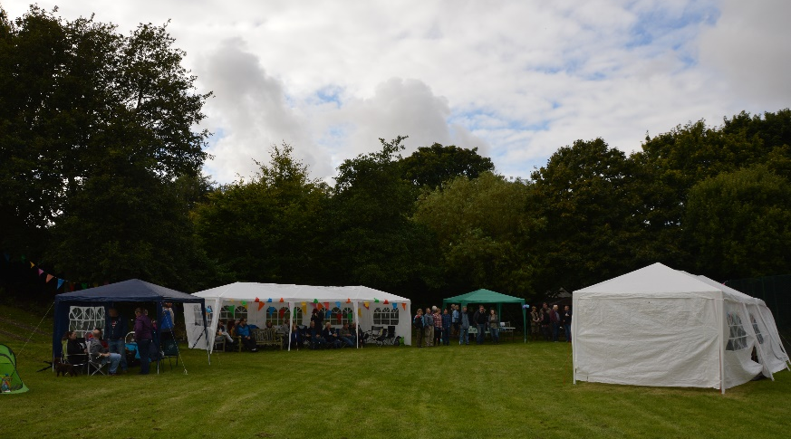
The field had been pampered and planted up in the weeks prior, and looked very smart. A collection of tents and marquees had been erected for audience comfort, the barbeque was set and the sausages and onions ready. The organising committee’s decision was rewarded with better than forecast weather and a very good turn out; around 60 hardy folk enjoyed a great afternoon of music and socialising.

The audience brought chairs and picnics and the odd tipple and settled down to a lovely variety of music from very talented musicians, gathered together by Morrison. The full line up was as follows:

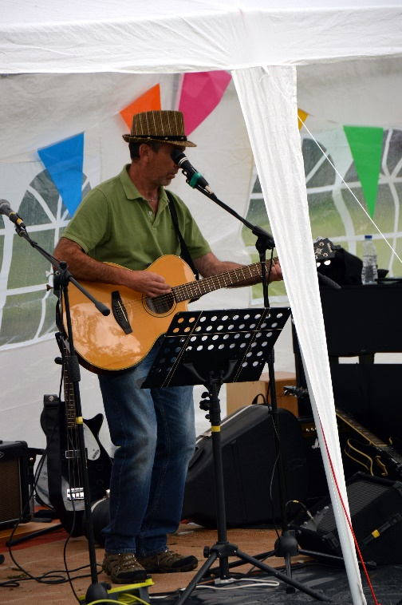
Adam "Punkwood" Bell: a very good singer with acoustic guitar who cleverly used a loop pedal for extra effect. He performed a variety of 80s & 90s popular songs that went down very well with the audience, kicking things off well.

Cliff Blakey & his shadow: an excellent flamenco guitarist and singer, whose performance was spotted by the Village Hall events group who have asked him to perform at the Mediterranean Night in October.

Keith "Telfy Boy" Telfer: a fine singer/acoustic guitarist from just over the A697 who played a well-received variety of very popular songs. Nice hat!

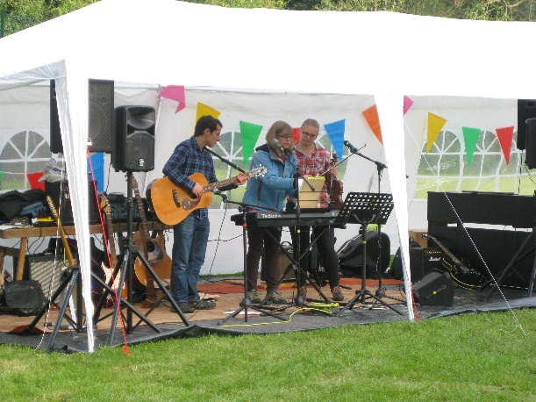
Frances, Charis and James : a very local trio, extremely talented, who played and sang Folk Music using keyboard, flute, violin and guitar with beautiful harmonies. Their acapella numbers were spellbinding.

The Dire Tates : a very talented five piece band (featuring a well-respected local musician) expertly covering favourites including Oasis, Kinks, Rolling Stones and Chuck Berry. (And by special request a Status Quo classic)

Delicious sausage sandwiches were expertly served by Margaret and Jane during the afternoon; Bill and Geoff slaved over a hot BBQ using the well known technique of “flambé” in order to avoid salmonella and law suits. Thanks go to the generosity of T. R. Johnson Butchers of Wooler, and Morrisons in Alnwick who donated the local sausages and buns/condiments respectively.

Special mention in dispatches must go to Judith and Andy for very kindly allowing us to plug into their house for the electricity. So much better than a noisy generator; thank you.

The whole ECA committee put a lot of hard work, time and thought into preparations for the event and it was satisfying to see so many folk having such a good time. The potential of the Parish Field for community events was well showcased and during the very efficient pack up operation several acts confirmed their interest for the next one and other residents offered to help with organising. Here’s hoping for better weather; see you next year.

